Writings

Name:

Period:

Self-Portrait Poems: Mentor Texts

Here are some mentor texts for your Self-Portrait Poems. Look through them to find one you want to emulate or mix them together, or come up with your very own structure. Strive for a balance of emotions - the witty with the gritty, the pain and the forgiveness. You have to keep asking yourself, “What does my memory mean? Why is the memory important? What does it say about me?” Challenge yourself and have FUN!

Remember also that poetry deals with emotions, just as music, art, and film do. An autobiographical poem is personal — it reveals something about the person writing the poem. It does not have to rhyme. It doesn’t have to be about something big. Often the most interesting stories are about little things — fishing one afternoon with your cousin, getting ready for your first dance, meeting your future stepfather for the first time, meeting your best friend, making a little mistake but learning a big lesson. Everyone has little moments that stick out in his or her mind. The key of course (and this is the hard part) is to find the memories or experiences that reflect who we are from among our ordinary details and memories

Where I’m From
by Bella, Kealing student

I am from the silk petals of a rose
From the cross around my neck
To the sticky, sweet mango juice
Dripping down my chin

I am from the blazing heat of Texas
To the unexpected blizzards of New Mexico
From catching the 6:30 am bus
To the screech of the school bell

I am from the scoring of the winning goal
From creamy vanilla ice-cream melting in my mouth
To the sandy golden beaches of California
I am from the sound of turning the crinkled pages of a book

From the strings of a guitar
To the tears of lost ones
I am from memorizing verses of the Bible
Day and night

From the cold of December
I am from the familiar smell of muffins in the oven
From the muddy paw prints on the front porch

To the cheerful Christmases we have each year
I am from the pride of Mexico
To the memorable moments of shouting for
Favorite soccer teams with family

I am from sour lemons that fall from the trees at my grandma’s
From tasting all kinds of different foods
To the crunching sound of orange, yellow, red and brown leaves
That have fallen from the trees in autumn

I am from laughing uncontrollably with my friends
From the love and acceptance of my family
To being unique
I am from being myself
I am me
I Am
by Zach, Kealing student

I am a computer-game playing eleven year old who loves to sleep in.
I wonder what Microsoft Office Word 2010 will look like
I hear the sound of my dreams even if I’m awake.
I see the Internet growing and evolving.
I want an AlienWare computer.
I am a computer-game playing eleven year old who loves to sleep in.

I pretend to be the master of the Internet.
I feel like I’m in the game.
I touch the other gamers’ hearts and minds with my arsenal.
I worry that I won’t have enough time to do my assignments.
I cry when I get very frustrated with anything.
I am a computer-game playing eleven year old who loves to sleep in.

I understand my parents love me.
I say America’s Funniest Home Videos is extremely funny.
I dream that I can fly sometimes.
I try to do my work in time.
I hope I will do well at Kealing.
I am a computer-game playing eleven year old who loves to sleep in.

I remember when my favorite games were new.
I am thrilled when I solve a puzzle in a game.
I build Legos when I get bored with the computer.
I dislike being tired.
I love weekends.
I am a computer-game playing eleven year old who loves to sleep in.

Questions
by Mallory, Kealing student

I am eleven years old.
I have strawberry-blonde hair that’s actually mostly brown.
I like to dance and play sports and read.
I take the bus to and from my middle school every day.
I’m not too different or unique from everybody else.
But sometimes it feels like I am.
Sometimes it feels like everybody know what to do
and how to do it except me.
And sometimes I’ll think about it until my head hurts,
and I still won’t get an answer.
Why am I me?
Why is everybody else who they are?
How come I’m not someone else with a different life
and a different personality?
How come I was born here and not there?
Why are we here and what is our purpose?
But still, no answer.
But sometimes people will ask me
what I want to be when I grow up.
And it’s hard to know what you want to be when you grow up
when you don’t even know what you want to have for lunch.
And sometimes I’ll think about all the things
I don’t know or understand,
but that doesn’t take too long.
And all of these things go on inside my brain,
which is covered by my skull,
which is covered by my strawberry-blonde hair
that’s actually mostly brown.

After All, This is America
by Ella, Kealing student

America – that smart, dumb, huge, spectacular country
where somehow, everyone fits in.

My whole life up to this point
Has been filled with people.
People laughing, people crying, people harming
People in pain
So many of each.
I’ve tried to help; I’ve tried to stop it
But what can I do?
Thinking, worrying, crying won’t help.
Won’t stop the bullying
Won’t cease the wars.
After all, this is America.

Of all the millions of people,
I feel like the one without a place,
Without a thing worth fighting for.
Everyone seems to know exactly who they are and
Where they are going in life.
Not me.
Not yet.
Those things take time.
Time that I don’t have.
After all, this is America.

Have you?
Have you figured out exactly where you belong?
Are you a laugher? A crier? A harmer?
A person in pain?
You choose.
You decide.
Life will play itself out and lead you there in the end.
After all, this is America.

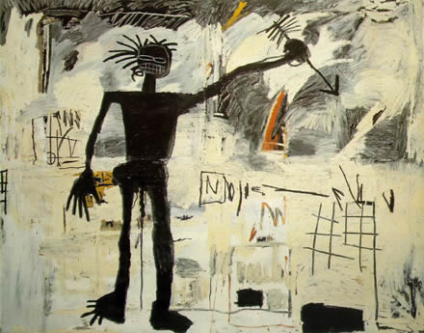
Jean-Michel Basquiat, Self-portrait, 1982.

Theme For English B
by Langston Hughes

The instructor said,

Go home and write
a page tonight.
And let that page come out of you--
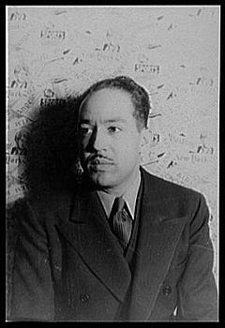
Then, it will be true.

I wonder if it's that simple?
I am twenty-two, colored, born in Winston-Salem.
I went to school there, then Durham, then here
to this college on the hill above Harlem.
I am the only colored student in my class.
The steps from the hill lead down into Harlem,
through a park, then I cross St. Nicholas,
Eighth Avenue, Seventh, and I come to the Y,
the Harlem Branch Y, where I take the elevator
up to my room, sit down, and write this page:

It's not easy to know what is true for you or me
at twenty-two, my age. But I guess I'm what
I feel and see and hear, Harlem, I hear you:
hear you, hear me--we two--you, me, talk on this page.

(I hear New York, too.) Me--who?
Well, I like to eat, sleep, drink, and be in love.
I like to work, read, learn, and understand life.
I like a pipe for a Christmas present,
or records--Bessie, bop, or Bach.
I guess being colored doesn't make me not like
the same things other folks like who are other races.
So will my page be colored that I write?
Hughes, photographed by Carl Van Vechten,1936.

Being me, it will not be white.
But it will be
a part of you, instructor.
You are white--
yet a part of me, as I am a part of you.
That's American.
Sometimes perhaps you don't want to be a part of me.
Nor do I often want to be a part of you.
But we are, that's true!
As I learn from you,
I guess you learn from me--
although you're older--and white--
and somewhat more free.

This is my page for English B.

Salvador Dali, Soft Self-portrait with Fried Bacon , 1941.

Just because
By unknown (non-Kealing) student

Just because I'm half Japanese
I'm not a California roll
I'm not a Sony TV or radio
I'm not a Toyota or a Nissan
Just because I'm half Japanese
I don't like being considered one race
I do like being considered a Jew
I'm not a "mixed up person"
Just because I'm half Japanese
I do like things that you do like to do
I do like and listen to hip hop
I do like and play basketball
Just because I'm half Japanese
What is race?
Is there a thing called race?
Can't you just like me because I'm me?
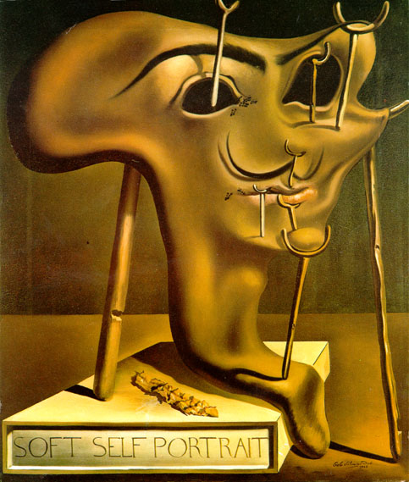
I think so.
Who am I?
by Louis, Kealing student

I am...
A clever brother
An imaginative son
An intelligent grandson
A goofy nephew
A carefree cousin
Sitting in the back of the car,
Startling my aunt and uncle with funny noises

I am...
A hilarious cartoonist
An intriguing author
An odd thinker
A skilled bassist
Happy to be a cartoonist
Because I enjoy seeing my ideas on paper

I am...
Taller than most 6th graders
Topped with crazy, tangly hair
Getting braces to fix my crooked teeth
Distinctive with the closest thing I’ll get to an Afro

I am...
Creative (I have endless comic ideas)
Silly (I come up with the weirdest things)
Lucky that my creative mind makes it easy to write comics

I am...
me

Questions to generate ideas for your self-portrait poem (and help you think about the “real” you):
- What are you thinking about when you're not thinking?
- What makes you mad?
- What makes you happy?
- What past events were turning points in your life that you'd like to understand?
- What are the distinctive things that make you "you"?
- How do you want people to see you?
- How can you express your many different sides?
- How can you reinvent yourself for various purposes or times in your life?
- How are you changing from day to day or year to year?
- Who do you want to become?

Instructions for writing your self-portrait poem:
Write a poem of one to two pages, typed double-spaced, which reveals your personality. You may choose to use one or more of the above sample poems as mentor texts, modeling your poem after their structures. Or you may choose to invent your own structure.

Review the Self-Portrait Poem Rubric as you work on your poem and make sure that you are meeting the criteria.

