BOOK LIST for 6th Grade Magnet English: World Literature

Welcome to World Literature! This is your book list for the 2014-15 school year.
- Choose ONE book to read from the eight memoir choices listed below, and bring it to class by Thursday, September 11th (A day), or Friday, September 12th (B day). If your student does not have a book in class that day, he/she may be assigned a memoir by the teacher.
- You will eventually also need to have a copy of both:
  - When My Name Was Keoko (which you will bring to class in November) and
  - The Book Thief (which you will bring to class in January).
*Financial assistance is available. Please notify your student’s English teacher as soon as possible if assistance is needed with purchasing these titles.
*Ayuda económica está disponible. Por favor de notifiquar al a maestra de lectura de su estudiante cuanto antes si la ayuda se necesita con la compra de estos títulos.

You may buy these books from any source you like. Book People will host a fundraiser for Kealing from Sunday, September 7th to Saturday, September 13th (separate flyer forthcoming), and we have asked that copies of all of these books be available to purchase. You may also consider shopping at used bookstores, like Half-Price Books, or ordering books online with merchants like www.amazon.com, and www.barnesandnoble.com. Students may check out books from the library, but there are limited copies available, and it will be more difficult to annotate a book that you are borrowing.

MEMOIR CHOICES (choose only ONE of the eight memoir options below)

Bad Boy by Walter Dean Myers
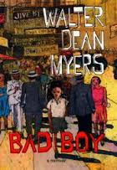
"’I didn't want to be defiant. I wanted to be in the system that I was walking away from, but I didn't know how to get in.’ Many teens will see themselves in Myers' account of his troubled coming-of-age, especially since he offers no pat solutions. He doesn't analyze or laugh at his youth from an adult perspective, and he doesn't overdramatize his childhood self. He remembers how he felt: detached, hurt, lonely, ashamed, a failure. He loved his Harlem neighborhood, but it was hard being black and poor and a reader, especially since moving into a world of books isolated him from those around him. He was big and physically aggressive, quick to get angry and punch kids who laughed at his speech defect. He was always in trouble at school and often truant. ...” www.amazon.com (Hazel Rochman, American Library Association)

Boy by Roald Dahl
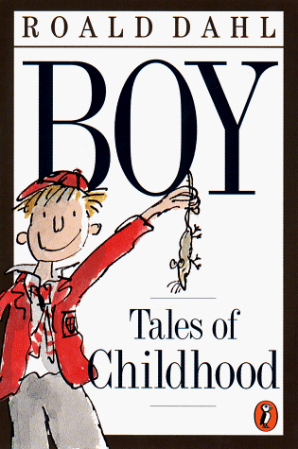
“In this rollicking romp through his childhood, Roald Dahl's [readers] glimpse some of the imaginative inspirations for his delightful stories. We spend idyllic summers in his mother's native Norway, grow weary at the boredom of his English public schools, wince at the canings administered to 7-year-old boys by 40-year-old psychopaths, even find a real live chocolate factory that gives free samples to young boys. Yet we relish every minute. The author covers all in the rosy hue of nostalgia …” --- www.amazon.com (AudioFile)

Chinese Cinderella: The True Story of an Unwanted Daughter by Adeline Yen Mah
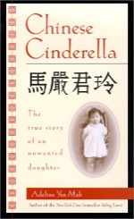
“… Blamed for the loss of her mother, who died shortly after giving birth to her, Mah is an outcast in her own family. When her father remarries and moves the family to Shanghai to evade the Japanese during WWII, Mah and her siblings are relegated to second-class status by their stepmother. They are given attic rooms in their big Shanghai home, they have nothing to wear but school uniforms, and they subsist on a bare-bones diet while their stepmother's children dine sumptuously. Mah finds escape from this emotionally barren landscape at school, but the academic awards she wins only enrage her jealous siblings and stepmother, and she is eventually torn from her aunt – her one champion – and shipped off to boarding school. ...” --- www.barnesandnoble.com (Publishers Weekly)
The Circuit: Stories from the Life of a Migrant Child by Francisco Jimenez
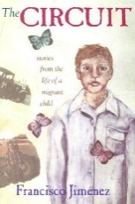
“Jimenez has created a moving autobiography that some critics have compared to John Steinbeck's Grapes of Wrath. The story … begins in Mexico when the author is very young and his parents inform him that they are going on a very long trip to ‘El Norte.’ What follows is a series of stories of the family's unending migration from one farm to another as they search for the next harvesting job. ... The backbreaking work and the soul-crushing effect of the endless packing and moving are portrayed through a child's dismay at having to leave a school where he has just gotten comfortable or, worse, having to miss several months of a school year in order to work. Panchito's desire to help his family by working in the fields often clashes with his academic yearning. …” --- www.amazon.com (Publishers Weekly)
Grayson by Lynne Cox
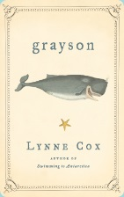
“In a simple but suspenseful narrative, the author recounts her mystical encounter with a baby whale and his mother on a March morning 30 years ago. Then 17 years old, Cox was just completing her swim off Seal Beach, CA, and heading toward shore when the ocean became unusually rough and swarming with small fish. A large animal that she at first mistook for a shark was swimming just beneath her. In fact, it was an 18-foot-long baby gray whale. Cox was frightened and then enchanted by the playful creature that seemed to want to follow her to shore, an act that would be fatal for him. ...” --- www.amazon.com (School Library Journal)

Knucklehead by John Scieszka
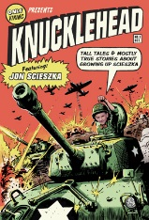
“Offering an answer to the perennial query about where his ideas come from, the National Ambassador for Young People's Literature looks back to his early 1960s youth. Fans will not be surprised to learn that, except for his mother (a nurse, fortunately) he grew up in an all-male household: father, five brothers and ‘even our dogs and cats and fish.’ The resulting memories include group pukes in the back seat, slipping toy soldiers into the Christmas creche, playing neighborhood games like ‘Slaughterball’ and idyllic summer expeditions into the woods around his grandparents' cottage-not to mention the pleasures of random dips into the household children's encyclopedia and spurning ‘those weirdos Dick and Jane’ to ‘find out more about real things like dogs in cars and cats in hats.’ Illustrated with truly dorky school-yearbook photos and family snapshots ...” --- www.barnesandnoble.com (Kirkus Reviews)

March: Book One by John Lewis, Andrew Aydin and Nate Powell
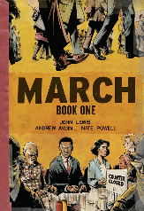
Congressman John Lewis … is an American icon, one of the key figures of the civil rights movement. His commitment to justice and nonviolence has taken him from an Alabama sharecropper's farm to the halls of Congress, from a segregated schoolroom to the 1963 March on Washington, and from receiving beatings from state troopers to receiving the Medal of Freedom from the first African-American president. Now, to share his remarkable story with new generations, Lewis presents March, a graphic novel trilogy, in collaboration with co-writer Andrew Aydin and New York Times best-selling artist Nate Powell … Book One spans John Lewis' youth in rural Alabama, his life-changing meeting with Martin Luther King, Jr., the birth of the Nashville Student Movement, and their battle to tear down segregation through nonviolent lunch counter sit-ins, building to a stunning climax on the steps of City Hall. --- www.amazon.com

My Thirteenth Winter: A Memoir by Samantha Abeel
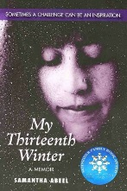
“… Abeel recounts her life, from kindergarten through college, with a learning disability ... She writes frankly about her mental and emotional struggles to cope; while she looked like a "normal" child, she was unable to tell time, count change, or remember her locker combination. Her narrative is interjected with first-person remembrances of painful incidents that left a vivid imprint on her self-worth. After her disability was diagnosed, halfway through her story when she was in seventh grade, the school system provided both special and gifted classes that helped her. But still aching over missed social opportunities and suffering from panic attacks, she turned to writing, which became her life preserver...” --- www.amazon.com (Julie Cummins, American Library Association)

BOTH OF THE FOLLOWING BOOKS ARE REQUIRED

When My Name Was Keoko by Linda Sue Park (which we will start in NOVEMBER)
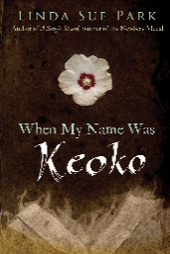
“Sun-hee; her older brother, Tae-yul; and their family are proud of their Korean heritage. But it is 1940, and they live under Japanese occupation. All students must read and write in Japanese, and no one can fly the Korean flag. Hardest of all is when the Japanese emperor forces all Koreans to take Japanese names. Sun-hee and Tae-yul become Keoko and Nobuo. During World War II, Korea is torn apart by the Japanese invaders. Everyone must help with war preparations, but although people have Japanese names, that doesn’t mean they are willing to defend Japan. Tae-yul is about to risk his life to help his family, while Sun-hee stays home guarding life-and-death secrets. Who knows whether they will ever meet again?” --- Book cover excerpt

The Book Thief by Markus Zusak (which we will start in JANUARY)
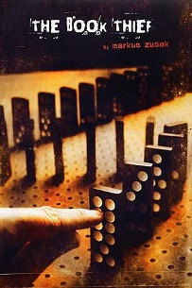
“It is 1939. The country is holding its breath. Death has never been busier, and will become busier still. By her brother’s, graveside, Liesel Meminger’s life is changed when she picks up a single object, partially hidden in the snow. It is The Grave Digger’s Handbook, left there by accident, and it is her first act of book thievery. So begins a love affair with books and words, as Liesel, with the help of her accordion-playing foster father, learns to read. Soon she is stealing books from the Nazi book-burnings, the mayor’s wife’s library, wherever there are books to be found. But these are dangerous times. When Liesel’s foster family hides a Jew in their basement, Liesel’s world is both opened up and closed down. In superbly crafted writing that burns with intensity, award-winning author Markus Zusak has given us one of the most enduring stories of our time.” --- Book cover excerpt

